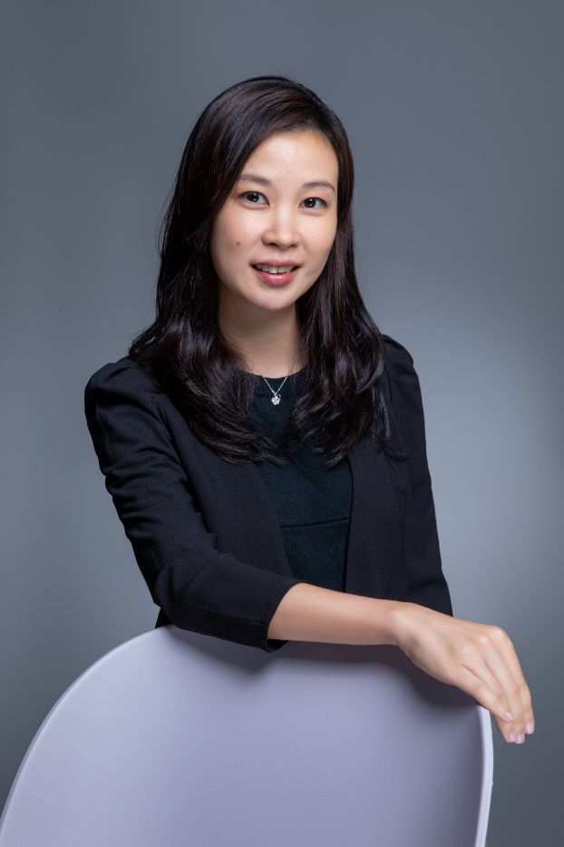

**YAM WING SZE**

SENIOR PHARMACEUTICAL MARKETING & BUSINESS UNIT MANAGER

***PROFESSIONAL ACHIEVEMENTS***

• Demonstrated excellence in stakeholder management, building trust with key opinion leaders, healthcare providers, patient groups, and policy makers to advance treatment adoption and patient outcomes.

• Skilled in regional and cross-cultural operations, with experience managing teams and projects across Hong Kong, Singapore, and the wider Asia-Pacific markets.

• Award-winning performance, including the Asia Pacific IMPACT Award (2021), reflecting exceptional contribution to regional strategy execution and business growth.

• Recognised expert in digital marketing governance, building omni-channel capabilities that improved engagement, ensured compliance, and supported customer-centric campaigns.

• Strong cross-functional leadership with the ability to align medical, sales, and marketing teams to deliver integrated brand strategies, ensuring consistent messaging, operational efficiency, and commercial success.

• Extensive experience in market access negotiations, achieving rapid product enlistment in government formulary without price erosion, through early stakeholder engagement and value-based propositions.

• Strategic leader in precision medicine, driving diagnostic adoption programs that significantly increased testing rates, improved early detection, and supported tailored treatment approaches for patients.

• Proven track record in successfully launching and managing complex pharmaceutical portfolios across oncology, hematology, neurology, cardiology, and renal therapy areas, with a focus on both solid tumors and rare diseases.

***OBJECTIVES***

To lead innovative marketing and business strategies in the pharmaceutical and oncology sectors, leveraging extensive experience across solid tumors, hematology, neurology, and rare disease portfolios. Passionate about driving market adoption of life-changing therapies, building cross-functional teams, and delivering measurable impact for patients, healthcare providers, and corporate stakeholders.

***SUMMARY***

Highly accomplished pharmaceutical leader with over 17 years’ experience spanning business unit management, strategic marketing, product launches, and market access across multiple therapeutic areas. Recognized for exceptional people management, ethical marketing, and precision medicine strategy execution. Proven track record in successfully launching new treatments, expanding diagnostic adoption, and forging strong stakeholder relationships to achieve commercial and patient outcomes.

***STRENGTHS & SKILLS***

• Strategic Marketing & Brand Management – from pre-launch to lifecycle optimization.

• Business Unit Leadership – cross-functional oversight, sales and marketing alignment.

• Precision Medicine – diagnostic strategy, stakeholder engagement, adoption programs.

• People Leadership – mentoring, coaching, and team development.

• Multi-Therapy Expertise – oncology, hematology, neurology, cardiology, renal.

• Cross-Cultural Communication – regional experience across Hong Kong, Singapore, and Asia-Pacific.

• Digital Marketing Governance – omni-channel strategy, digital operations, compliance oversight.

**CAREER HIGHLIGHTS**

* Over 15 years’ experience in pharmaceutical sales, marketing, and business management across oncology, hematology, neurology, cardiology, and renal therapeutic areas.
* Proven track record of successfully launching multiple oncology products, including breast, lung, prostate cancer, and hematology treatments, achieving rapid government sector enlistment.
* Led the precision medicine strategy at Novartis to increase diagnostic testing rates for solid tumour diseases, driving adoption in clinical practice.
* Appointed Digital Governance Champion for Oncology Business Unit (HK), implementing omni-channel strategies, digital operations, and local governance frameworks.
* Experienced people leader, managing and mentoring product and associate managers to achieve high-performance outcomes.
* Commercial lead for gene therapy pre-launch at Takeda, overseeing business strategy for cutting-edge treatments.
* Delivered successful market transitions, including negotiating with payers and converting product formulations without price cuts in the government sector.
* Recognised with multiple industry awards, including the Asia Pacific IMPACT Award (2021), BU Sales Award (2009), and Super Salesman Award (2007).
* International experience through a marketing assignment in Singapore, contributing to regional launch strategies and training initiatives.
* Strong ethical marketing skills, stakeholder engagement expertise, and excellence in oral and written communications.

**MAJOR AWARDS**

• **Asia Pacific IMPACT Award, Novartis HK Ltd – Mar 2021**  
Recognised for outstanding contribution to the Oncology Business Unit in the Asia Pacific region, delivering exceptional business results through innovative marketing strategies, cross-functional collaboration, and impactful stakeholder engagement.

• **BU Sales Award, Roche HK Ltd – Jan 2010**  
Honoured for exceptional sales performance within the Business Unit, exceeding targets through strategic account management, effective product positioning, and strong customer relationships in a highly competitive oncology market.

• **Super Salesman Award, UCB Pharma Ltd – Feb 2007**  
Awarded for top-tier sales achievement across the company, demonstrating exceptional territory growth, product adoption, and client retention within neurology and cardiology therapeutic areas.

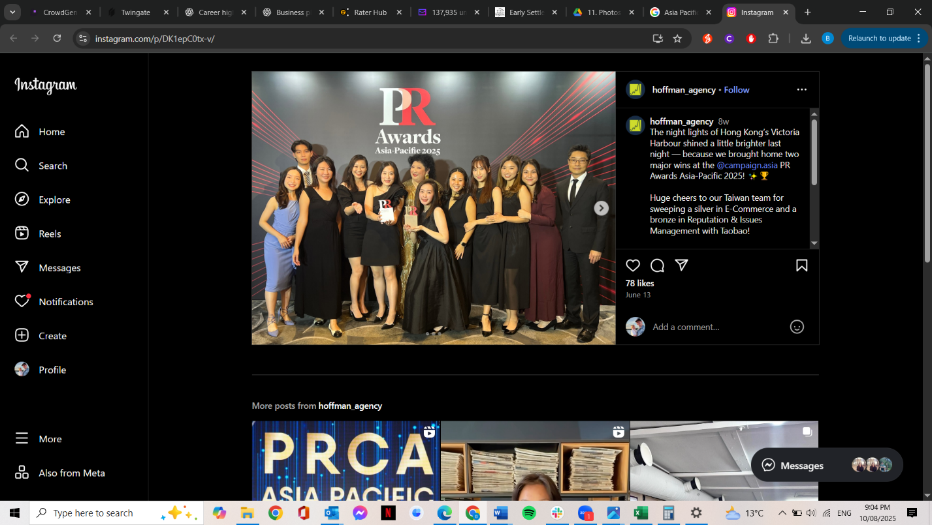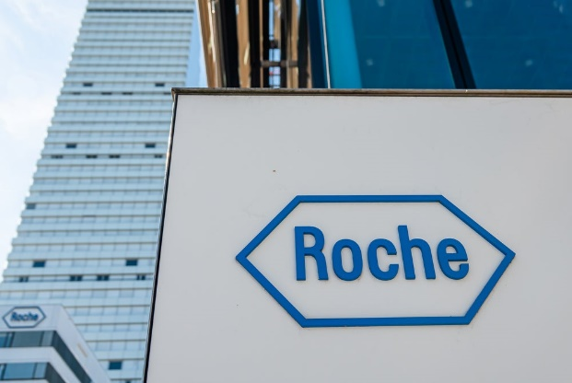

**EDUCATION**

**School of Continuing & Professional Studies**

CUHK – Professional Diploma in Marketing

(Part-time) (Apr 2008 – Dec 2008)

**The Chinese University of Hong Kong**

Master of Philosophy (M.Phil) in Chinese Medicine (Research Based)

(Sep 2003 – Aug 2005)

**The Chinese University of Hong Kong**

Bachelor of Science (BSc) with Honours in Molecular Biotechnology

(Sep 2000 – Jul 2003)



**PROFESSIONAL MEMBERSHIPS**

Women in Leadership Australia (WLA) - **Associate Member 2025**

Australian Institute of Company Directors (AICD) – **Member 2025**

Life Sciences Queensland (LSQ) – **Member 2025**

# Women & Leadership Australia (WLA) grants for leadership development programs – Australian Society for Parasitology



**PROFESSIONAL EXPERIENCE**

**Takeda Pharmaceutical Hong Kong Ltd**  
**Business Unit Manager** | Aug 2023 – Present

* Lead the lung and prostate cancer portfolio (solid tumour) with full accountability for business strategy, P&L performance, and market expansion.
* Drive sales and marketing initiatives that strengthen brand positioning and accelerate growth in competitive oncology segments.
* Appointed **Commercial Lead for pre-launch gene therapy**, orchestrating cross-functional readiness, regulatory alignment, and market access planning for one of the company’s most innovative treatments.

**Novartis Pharmaceutical Hong Kong Ltd**  
**Marketing Manager** | Oct 2022 – Aug 2023

* Directed end-to-end marketing strategy for the breast cancer portfolio, delivering impactful campaigns that reinforced market leadership and addressed key patient and physician needs.
* Managed and developed an Associate Product Manager, fostering skills in brand management, market analysis, and campaign execution.
* Strengthened stakeholder relationships across the healthcare ecosystem, enabling faster adoption of targeted therapies.

***Associate Marketing Manager*** | Oct 2021 – Sep 2022

* Led the marketing for lung cancer and melanoma portfolios, aligning product strategy with emerging clinical data and treatment guidelines.
* Designed and executed **precision medicine strategies** that significantly improved diagnostic testing rates for solid tumour patients, enabling earlier and more targeted treatment interventions.
* Oversaw and coached an Associate Diagnostic Manager, driving integration of diagnostic solutions into the overall oncology strategy.

***Senior Product Manager*** | Sep 2020 – Sep 2021

* Directed hematology product portfolio strategy, achieving market growth through targeted campaigns, KOL engagement, and competitive positioning.
* Served as **Digital Governance Champion** for the Oncology Business Unit, creating and enforcing governance frameworks, optimising omni-channel execution, and ensuring compliance across digital initiatives.
* Mentored Associate Product Managers, enhancing the team’s capability to deliver innovative, compliant, and patient-centred marketing solutions.

**Novartis Pharmaceutical Singapore Pte Ltd**  
**Marketing Assignment (3 months)** | Feb 2020 – Apr 2020

* Spearheaded **new indication launch planning**, including market analysis, pricing strategy, and cross-market alignment for product rollout.
* Delivered training and knowledge-sharing sessions to empower the Singapore team with best practices from the Hong Kong market.

**Novartis Pharmaceutical Hong Kong Ltd**  
**Product Manager** | Nov 2016 – Aug 2020

* Achieved a **seamless product formulation transition** in the hematology portfolio without implementing government price cuts, safeguarding profitability while maintaining market share.
* Developed and executed marketing strategies that consistently met or exceeded growth targets.
* Acted as Digital Governance Champion, standardising digital operations and omni-channel approaches across the Oncology BU.

**Roche Hong Kong Ltd**  
**Associate Product Manager** | Apr 2015 – Oct 2016

* Successfully launched a new oncology product (breast cancer) through **early multi-stakeholder engagement**, achieving rapid government sector enlistment and accelerated patient access.
* Created and implemented marketing plans in line with corporate objectives and local market needs.

**Senior Executive, Marketing** | Jun 2012 – Mar 2015

* Supported oncology product managers in the creation and roll-out of marketing campaigns, events, and KOL programs, contributing to brand growth and market penetration.

**Senior Executive, Sales** | Apr 2011 – May 2012

* Managed sales and marketing activities for renal products, consistently meeting or surpassing revenue targets.

**Product Specialist** | Apr 2009 – Apr 2011

* Built strong customer relationships with nephrologists and dialysis centres, driving adoption of renal products through value-focused engagement.

**UCB Pharma Ltd**  
**Product Specialist** | Sep 2008 – Mar 2009

* Managed neurology (epilepsy) and cardiology (anti-hypertensive) portfolios, increasing market presence through targeted sales initiatives.

**Medical Representative** | Mar 2008 – Aug 2008

* Delivered sales growth across primary care, dermatology, paediatrics, and ENT portfolios by building trust-based relationships with healthcare providers.

**Baxter Healthcare Ltd**  
**Regulatory Affairs Specialist (Contractor)** | Dec 2005 – Jun 2006

* Oversaw pharmaceutical product registration processes, liaising with global regulatory teams to ensure timely approvals and compliance with local standards.

**CONFERENCES AND EVENTS**

**ESMO Asia Congress 2023 – 19 ESMO-MORA**

**ESMO Asia Congress 2024 – 16 ESMO-MORA**

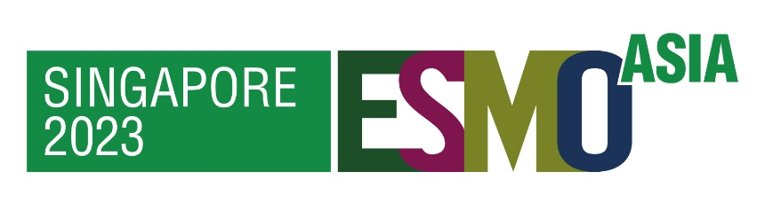

**PUBLICATIONS**

**Jiang, R.-W., Lau, K.-M., Lam, H.-M., Yam, W.-S., Leung, L.-K., Choi, K.-L., Waye, M. M.-Y., Mak, T. C.-W., Woo, K.-S., & Fung, K.-P.** (2005). A comparative study on aqueous root extracts of *Pueraria thomsonii* and *Pueraria lobata* by antioxidant assay and HPLC fingerprint analysis. *Journal of Ethnopharmacology, 96*(1–2), 133–138. <https://doi.org/10.1016/j.jep.2004.08.029>

**Please refer to my personal statement and comprehensive project lists for additional details and further information.**